**Chapter 8**

**RESULTS**

* Seaborn countplot shows the count in either of the diagnosis class, where ‘M’ represents 1 and ‘B’ represents 0 as shown in figure 8.1 below.

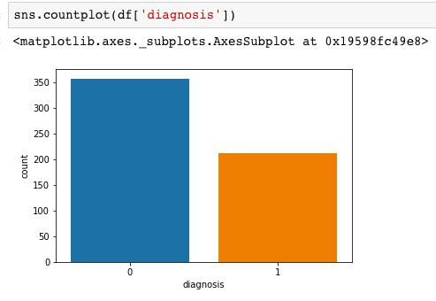

**Figure 8.1 Diagnosis Count**

* Matplotlib.pyplot.scatter showing the variation of ‘perimeter_mean’ with respect to ‘area_mean’ attributes of the size of the tumor. pandas.Dataframe.corr compute pairwise correlations of columns, excluding null/NA values as shown in figure 8.2 below.

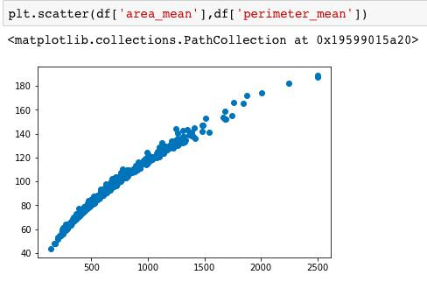

**Figure 8.2 Relation between average area and perimeter of the Tumor**

Department of CSE, RNSIT 2018-2019 38